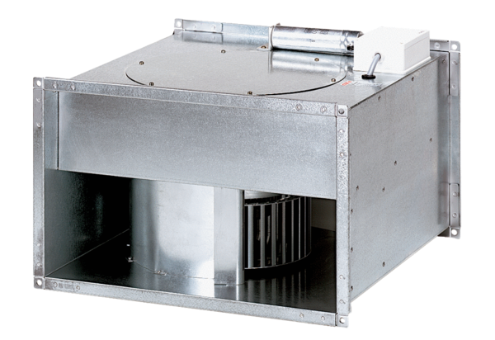Channel fan DPK 25/6 BPacking unit: 1 pieceRange: D
Article number: 0086.0662Manufacturer: MAICO

