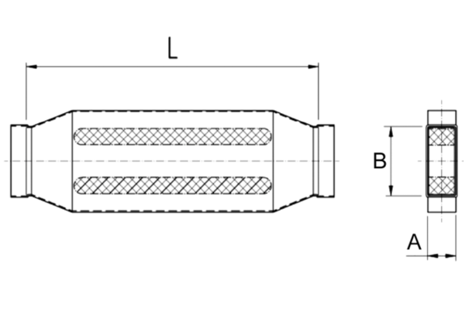40 mm channel sound absorbers with attenuating linging. KSD80/200/700Packing unit: 1 pieceRange: K
Article number: 0092.0456Manufacturer: MAICO

