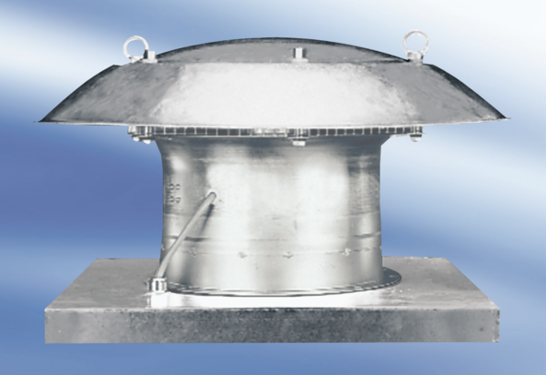Axial roof fan DZD30-2APacking unit: 1 pieceRange:
Article number: 0087.0416Manufacturer: MAICO

