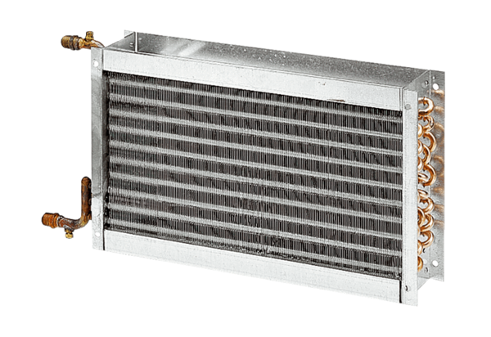Water air heater WHP 22-18Packing unit: 1 pieceRange: D
Article number: 0082.0111Manufacturer: MAICO

