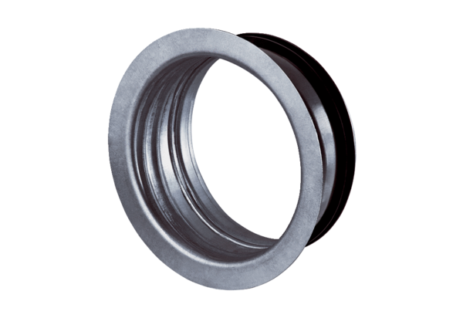Mounting frame for TFA/TFZ EBR-D 16Packing unit: 1 pieceRange: C
Article number: 0092.0496Manufacturer: MAICO

