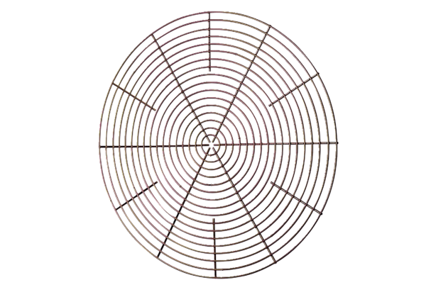Protective grille, metal SG 45Packing unit: 1 pieceRange: C
Article number: 0150.0119Manufacturer: MAICO

