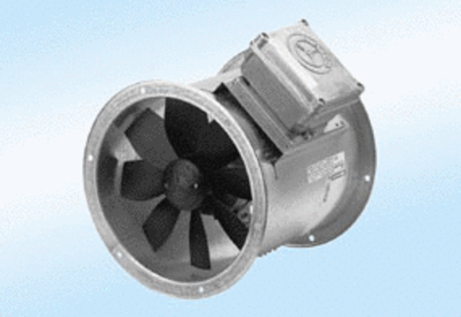Axial duct fan DZR 35/6 A-ExPacking unit: 1 pieceRange: C
Article number: 0086.0770Manufacturer: MAICO

