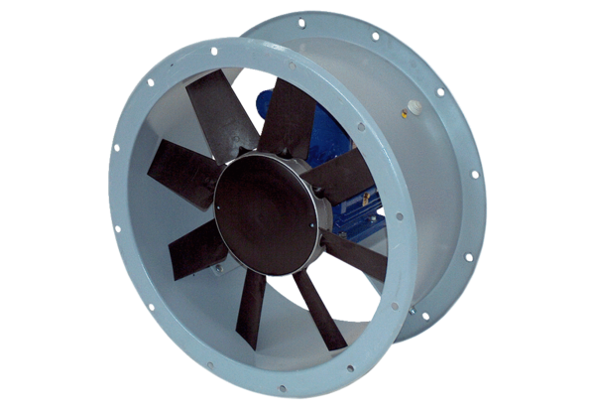Axial duct fan DAR 125/6 5,5Packing unit: 1 pieceRange: C
Article number: 0073.0186Manufacturer: MAICO

