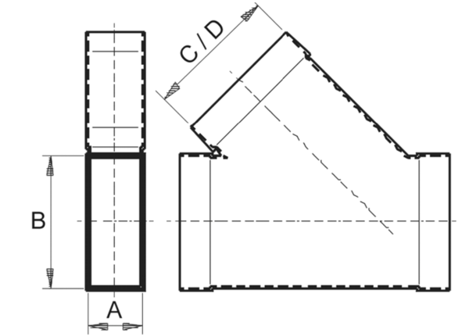45° branch, horizontal AZ45H55/220/55/220Packing unit: 1 pieceRange: K
Article number: 0055.0734Manufacturer: MAICO

