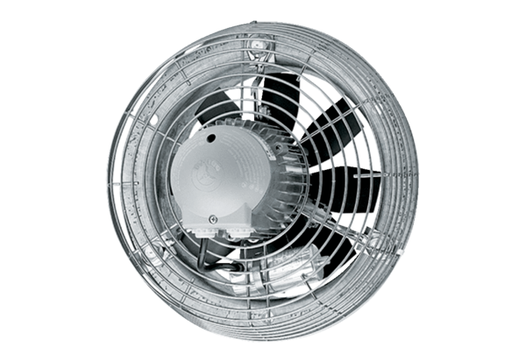Axial wall fan DZS 35/64 BPacking unit: 1 pieceRange: C
Article number: 0094.0046Manufacturer: MAICO

