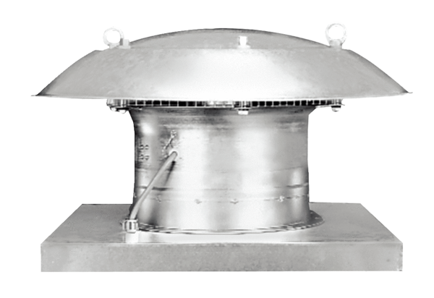Axial roof fan EZD 50/6 BPacking unit: 1 pieceRange: C
Article number: 0087.0211Manufacturer: MAICO

