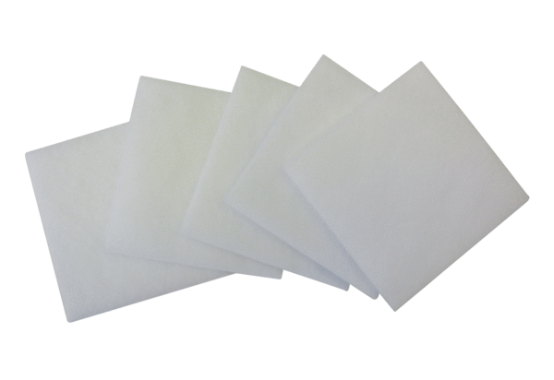Air filter, replacement ZF 17-1Packing unit: 5 piecesRange: B
Article number: 0093.0676Manufacturer: MAICO

