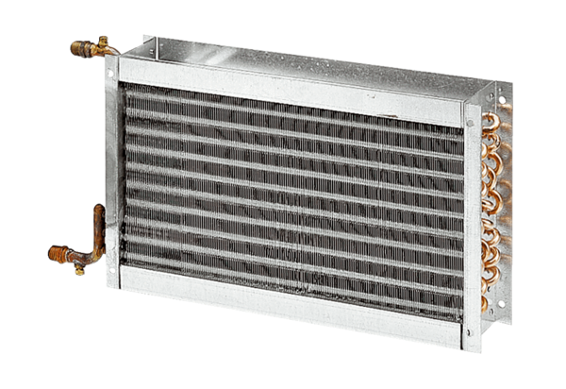Water air heater WHP 25-22Packing unit: 1 pieceRange: D
Article number: 0082.0112Manufacturer: MAICO

