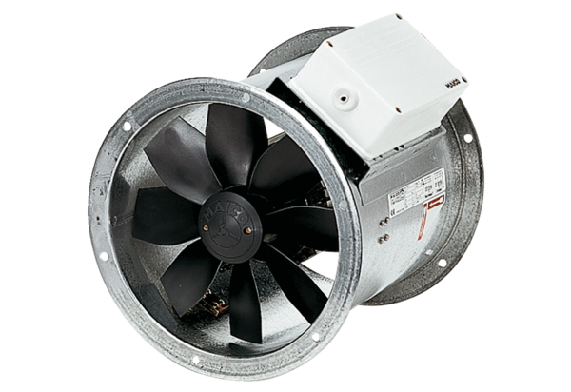Axial duct fan DZR 40/64 BPacking unit: 1 pieceRange: C
Article number: 0086.0049Manufacturer: MAICO

