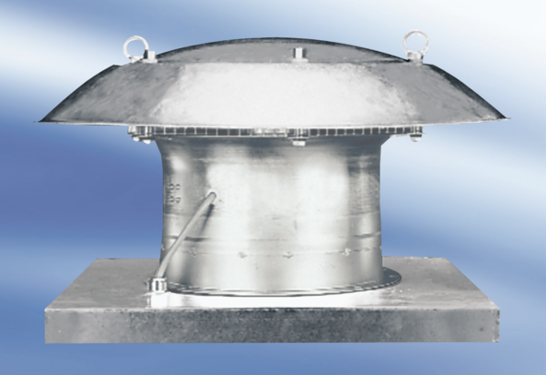Axial roof fan DZD50-6APacking unit: 1 pieceRange:
Article number: 0087.00425Manufacturer: MAICO

