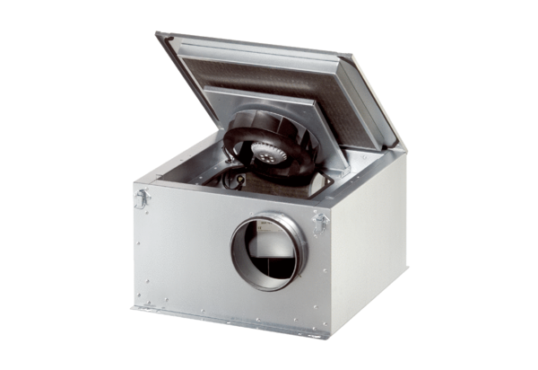Sound-insulated ventilation box DSR 40-2 SPacking unit: 1 pieceRange: C
Article number: 0080.0623Manufacturer: MAICO

