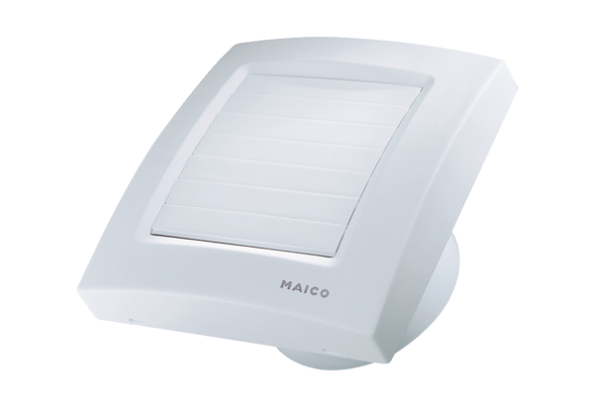Small room fan ECA 150/4KPacking unit: 1 pieceRange: A
Article number: 0084.0037Manufacturer: MAICO

