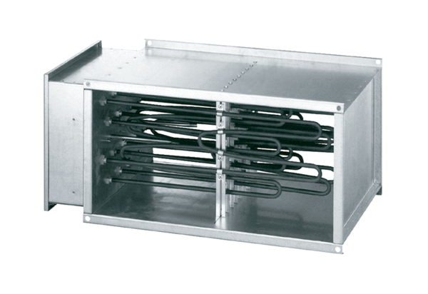Electrical air heater DHP 31-16Packing unit: 1 pieceRange: D
Article number: 0082.0099Manufacturer: MAICO

