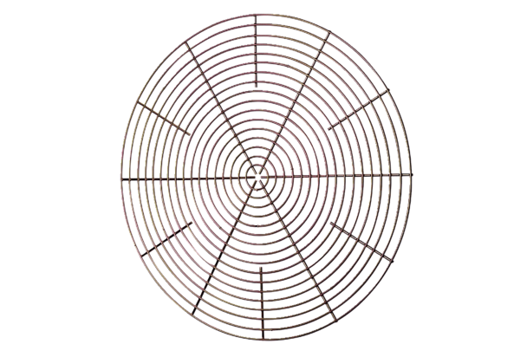Protective grille, metal SG 40Packing unit: 1 pieceRange: C
Article number: 0150.0118Manufacturer: MAICO

