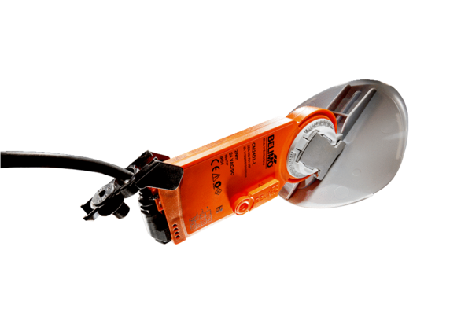Shutter drive with air damper MS 160Packing unit: 1 pieceRange: C
Article number: 0157.1234Manufacturer: MAICO

