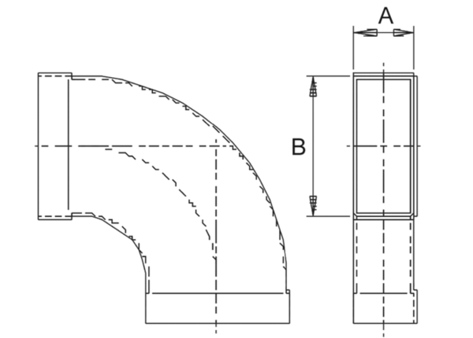90° channel elbows, long, horizontal KB90LH/80/150Packing unit: 1 pieceRange: K
Article number: 0055.0574Manufacturer: MAICO

