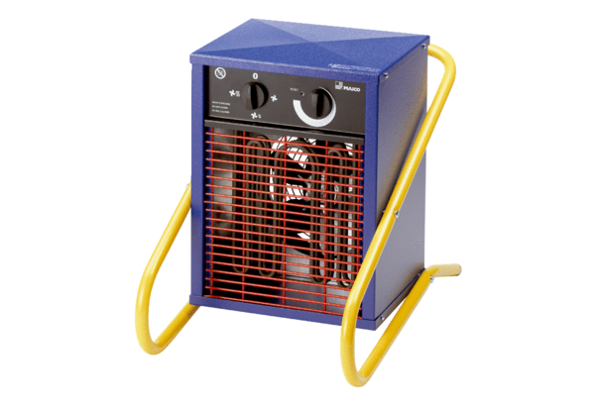Heater fan PHE 3Packing unit: 1 pieceRange: C
Article number: 0082.0065Manufacturer: MAICO

