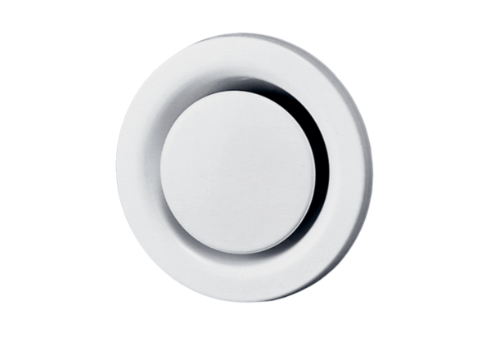Disk valve, metal TM 15Packing unit: 1 pieceRange: C
Article number: 0151.0195Manufacturer: MAICO

