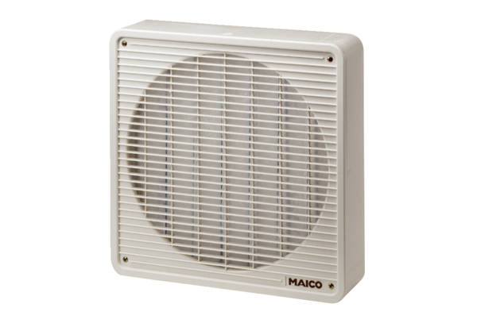Air filter ZFF 40Packing unit: 1 pieceRange: C
Article number: 0149.0005Manufacturer: MAICO

