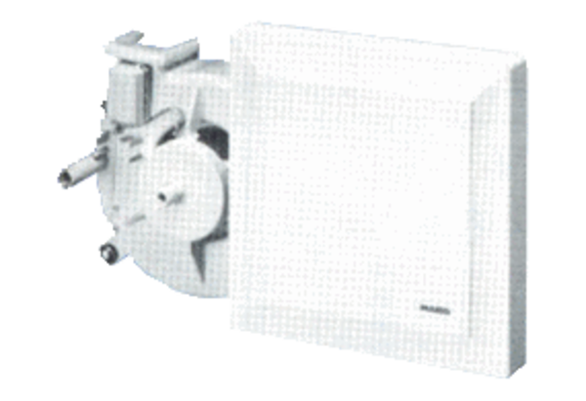Fan insert ER 17/60-2 FPacking unit: 1 pieceRange:
Article number: 0080.0784Manufacturer: MAICO

