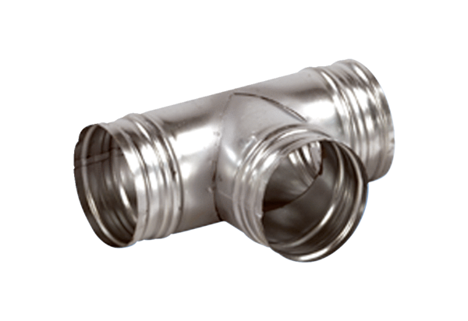90° branch AB 80-125Packing unit: 1 pieceRange: K
Article number: 0055.0347Manufacturer: MAICO

