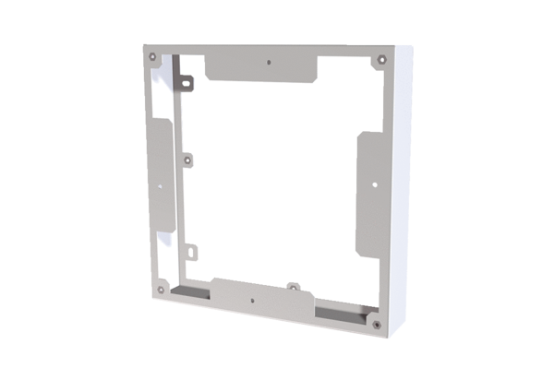Compensating frame PPB 30 ARWPacking unit: 1 pieceRange: K
Article number: 0093.1525Manufacturer: MAICO

