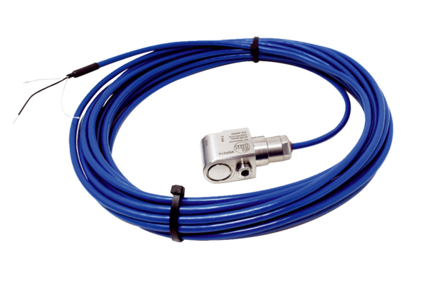Vibration sensor SWExPacking unit: 1 pieceRange: C
Article number: 0157.0303Manufacturer: MAICO

