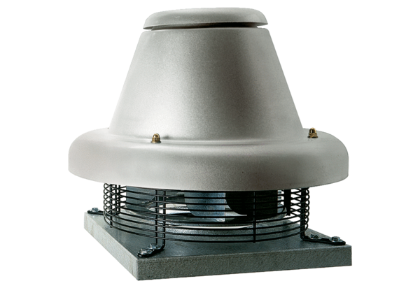Centrifugal roof fan DRD HT 35/4Packing unit: 1 pieceRange: C
Article number: 0073.0012Manufacturer: MAICO

