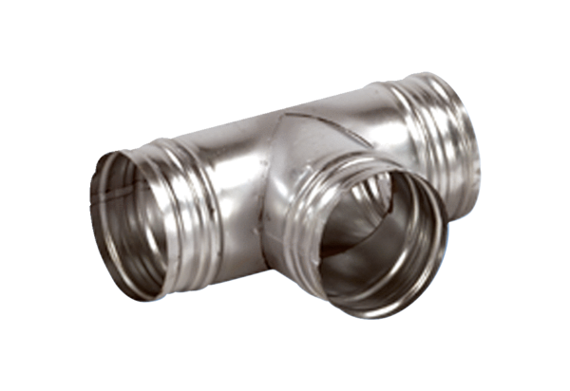90° branch AB 160-150Packing unit: 1 pieceRange: K
Article number: 0055.0370Manufacturer: MAICO

