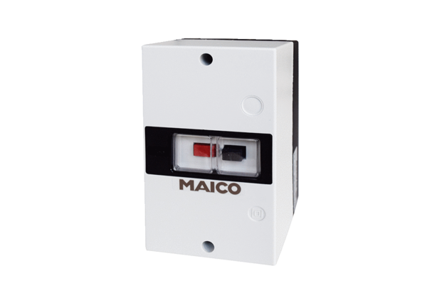Motor protection switch MV 25-1Packing unit: 1 pieceRange: C
Article number: 0157.1659Manufacturer: MAICO

