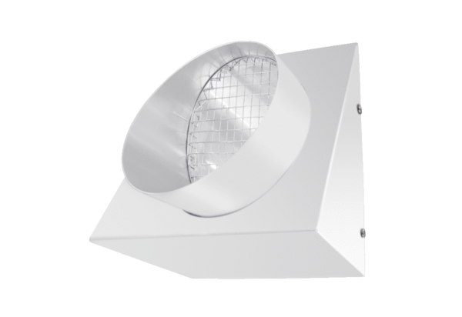Outgoing air wall connection KW-FL 20WPacking unit: 1 pieceRange: K
Article number: 0152.0084Manufacturer: MAICO

