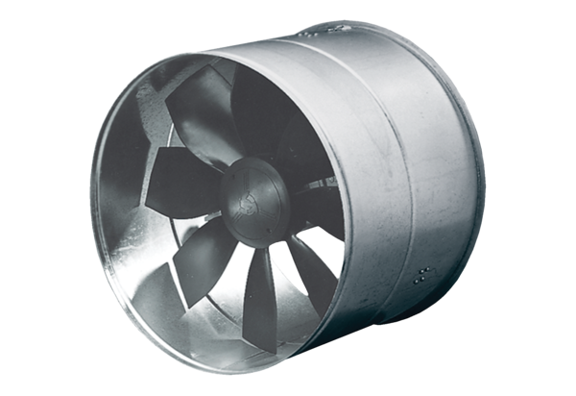AIROTHERM fan DZF 35/6 BHPacking unit: 1 pieceRange: C
Article number: 0085.0030Manufacturer: MAICO

