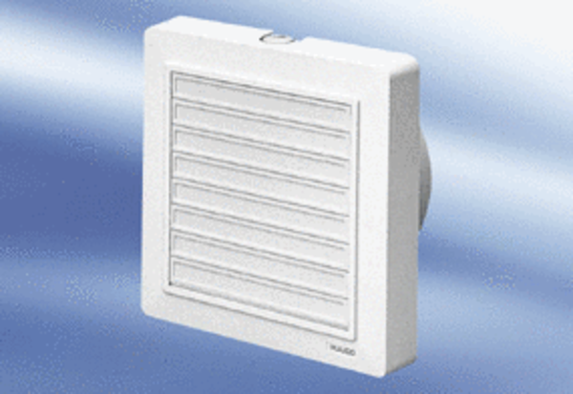Small room fan ECA 15/4 KFPacking unit: 1 pieceRange:
Article number: 0080.0979Manufacturer: MAICO

