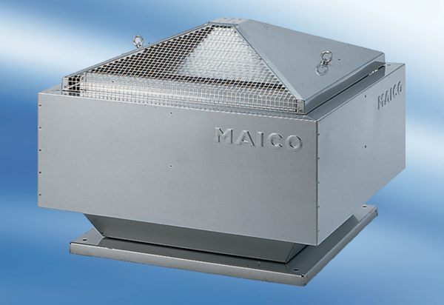Centrifugal roof fan DRD 50/64Packing unit: 1 pieceRange: C
Article number: 0087.0156Manufacturer: MAICO

