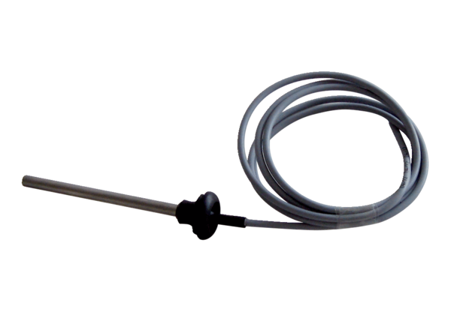Temperature sensor NTC 15Packing unit: 1 pieceRange: K
Article number: 0157.0833Manufacturer: MAICO

