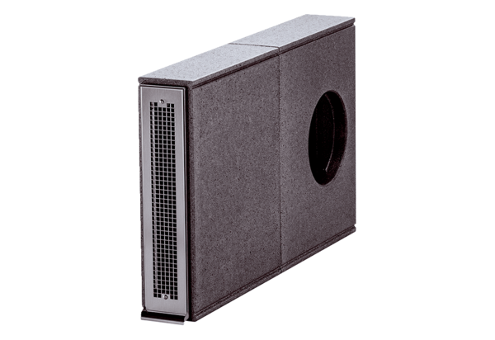Soffit element PP 45 LEPacking unit: 1 pieceRange: K
Article number: 0093.0179Manufacturer: MAICO

