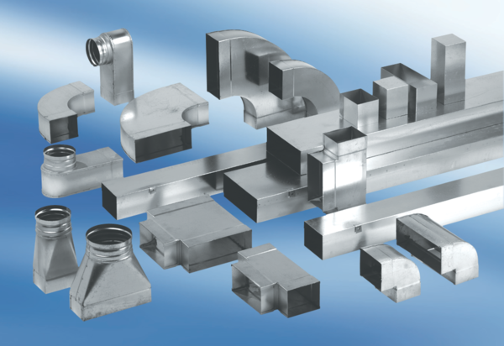90° angle elbow, left-sided asymmetrical WB90ALN55/220/125Packing unit: 1 pieceRange: K
Article number: 0055.0627Manufacturer: MAICO

