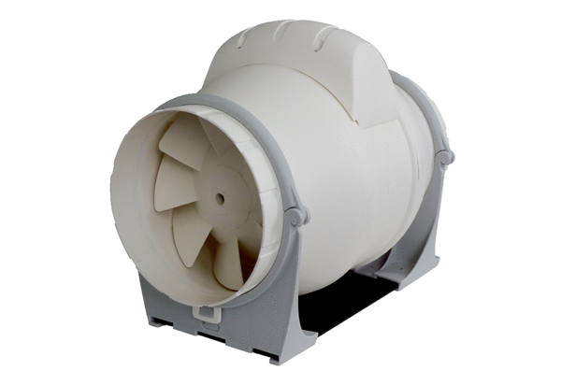Diagonal fan ERK 200Packing unit: 1 pieceRange: C
Article number: 0080.0181Manufacturer: MAICO

