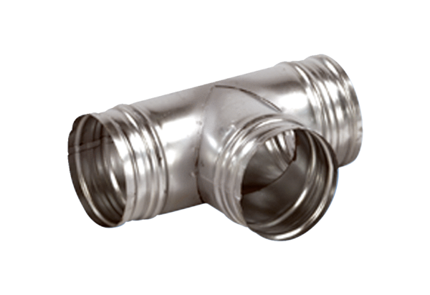90° branch AB 160-100Packing unit: 1 pieceRange: K
Article number: 0055.0368Manufacturer: MAICO

