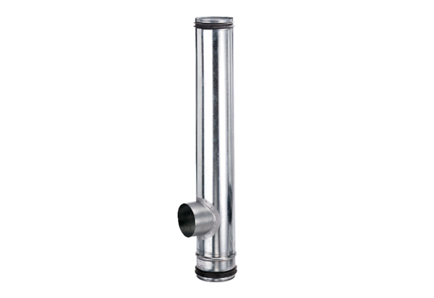Fire protection compensation element BA 160/100-1Packing unit: 1 pieceRange: B
Article number: 0093.1009Manufacturer: MAICO

