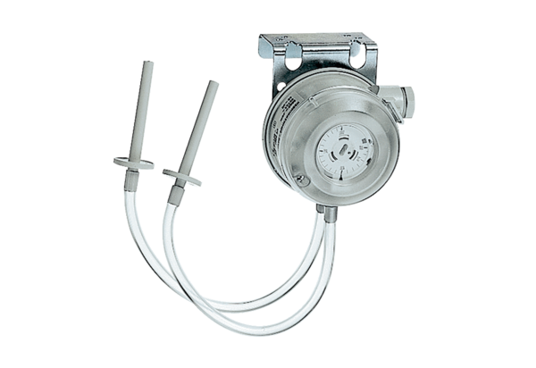Differential pressure controller DW 1000Packing unit: 1 pieceRange: D
Article number: 0157.0752Manufacturer: MAICO

