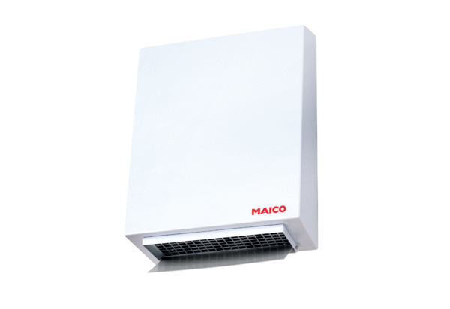Centrifugal external wall fan AWV 16 ECPacking unit: 1 pieceRange: E
Article number: 0073.0576Manufacturer: MAICO

