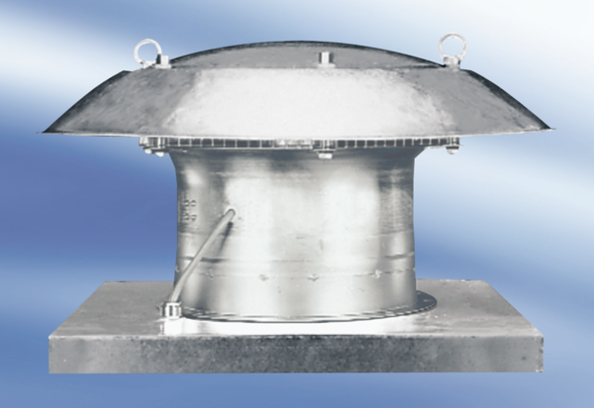Axial roof fan DZD 35/64 APacking unit: 1 pieceRange:
Article number: 0087.0440Manufacturer: MAICO

