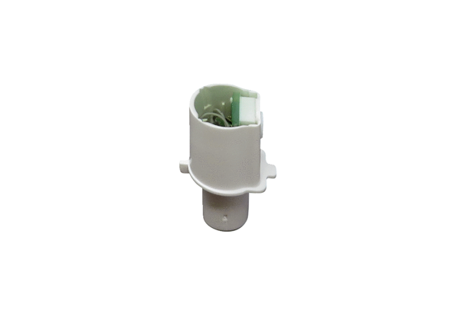Sensor SE ECA 100 ipro HRange: A
Article number: E157.0141.0000Manufacturer: MAICO

