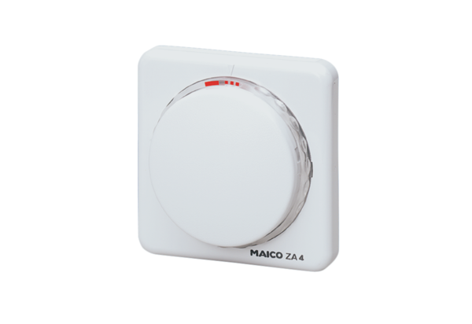Automatic timer ZA 4Packing unit: 1 pieceRange: A
Article number: 0157.0426Manufacturer: MAICO

