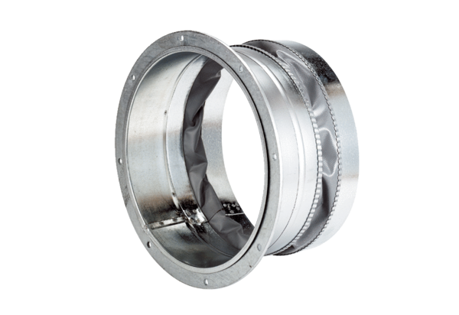Flexible coupling ELA 40Packing unit: 1 pieceRange: C
Article number: 0092.0269Manufacturer: MAICO

