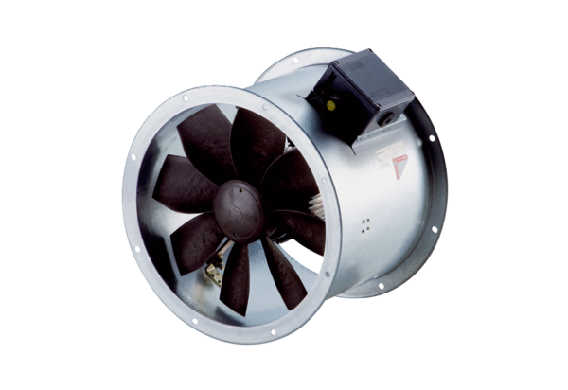Axial duct fan DZR 40/6 B Ex tPacking unit: 1 pieceRange: C
Article number: 0086.0729Manufacturer: MAICO

