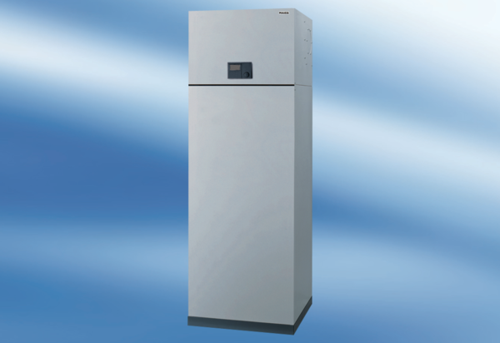Aeronom room air system AWP 200Packing unit: 1 pieceRange: K
Article number: 0095.0054Manufacturer: MAICO

