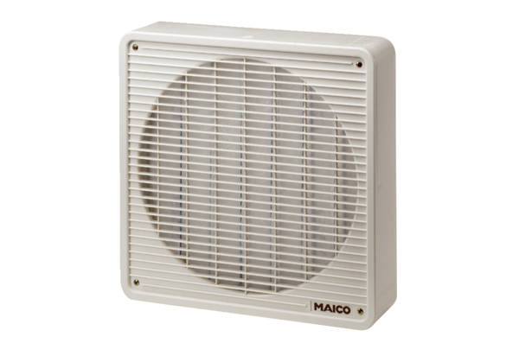Air filter ZFF 20Packing unit: 1 pieceRange: C
Article number: 0149.0001Manufacturer: MAICO

